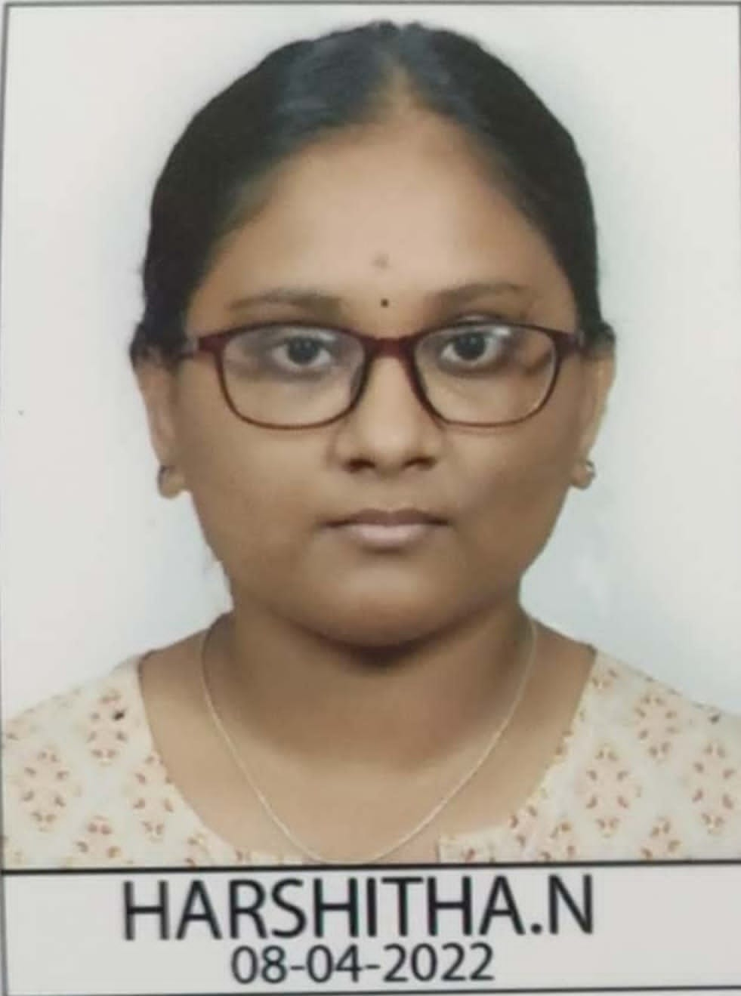
APPLICATION FOR ADMISSION
Medical Academy named after S.I. Georgievsky of
V.I. Vernadsky Crimean Federal University
2022/2023 academic year
Information about applicant
Surname |  |  | N
Given name(s) |  |  | HARSHITHA
Date of birth: DD-MM-YYYY |  |  | 18/2/2000
City, State, Country of birth |  |  | BANGALORE, KARNATAKA,INDIA
Citizenship |  |  | INDIAN
Marital status (indicate) |  |  | Married ☐ Single √
Gender |  |  | M ☐ F √ Others ☐
Permanent street address: |  |  | KAMANDAHALLI VILLAGE MAVAHALLI POST BANGARPET TALUK KOLAR DISTRICT
City |  |  | BANGALORE
State |  |  | KARNATAKA
Zip/Postal Code: |  |  | 563162
Country |  |  | INDIA
E-mail |  |  | harshithakmdl@gmail.com
WhatsApp phone number |  |  | 9901977804
Skype ID
Location of Embassy where you will apply for visa |  |  | DELHI
Additional information
Language 1 ___KANNADA_______________
Speaking ability: |  | Reading ability: |  | Writing ability:
High √ |  | High √ |  | High ☐
Moderate ☐ |  | Moderate ☐ |  | Moderate √
Low ☐ |  | Low ☐ |  | Low ☐
Language 2 _____________ENGLISH_________
Speaking ability: |  | Reading ability: |  | Writing ability:
High ☐ |  | High ☐ |  | High ☐
Moderate √ |  | Moderate √ |  | Moderate √
Low ☐ |  | Low ☐ |  | Low ☐
Other languages:
Please indicate the program you apply for:
☐ | Pre-medical course – 10 months
☐ | General Medicine (MD Physician) (in Russian) – 6 years
☒ | General Medicine (MD Physician) (in English) – 6 years
☐ | Pediatrics (in Russian) – 6 years
☐ | Dentistry (in Russian) – 5 years
☐ | Dentistry (in English) – 5 years
☐ | Pharmacy (in Russian) – 5 years
☐ | Post-graduate course
 | Signature
 | Date 20/12/2022
☐ | Consent to the collecting and processing of personal data.
Note: to receive original invitation please attach to this application letter: 1 – scanned copy of your national passport (first and last pages); 2 - scanned copies of your high school certificate and statement of marks.
CONSENT TO THE COLLECTING AND PROCESSING OF PERSONAL DATA
In accordance with Art. 9 of the Federal Law of 27.07.2006 No. 152-FZ "On Personal Data" I freely, by my own will and in my own interest, give the data to authorized representative persons of the V.I. Vernadsky Crimean Federal University for processing (any action (operation) or set of actions (operations), including collection, recording, systematization, accumulation, storage, clarification (update, change), extraction, use, transfer (distribution, provision, access), depersonalization, provision, deletion, destruction) of the following data: last name, first name and patronymic (previous last name, first name, patronymic, date, place and reason for the change (in case of change); information on citizenship (including previous citizenship, other citizenship); information about education (name and year of graduation from the educational organization, name and details of the educational document, qualifications, direction of study or information about education); academic degree; information on foreign language proficiency, level of proficiency; sports title, sports class; address and date of registration at the place residence, address of actual residence; contact phone number or information about other methods of communication; type, series, number of the identity document, the name of the issuing authority, date of issue; taxpayer identification number; number of insurance certificate of compulsory pension insurance; the details of the compulsory health insurance policy; attitude to conscription, information on military registration (for citizens who are in the reserve, and persons who are conscripted for military service); marital status, family composition; information about labor activity (including military service, part-time work, entrepreneurial activity, etc.); state awards, other awards and distinctions (by whom and when); class rank of the state civil service of the Russian Federation, state service of the Russian Federation, municipal service, diplomatic rank, military or special rank, class rank of law enforcement service; information on the presence or absence of a criminal record (for persons engaged in pedagogical activity); information about income, expenses, property and property obligations; the presence of any disease that prevents the conclusion of an employment relationship (training) or the execution of the absence of charges (training), confirmed by an inmate of a medical institution; information about staying abroad (when, where, for what purpose); admission to state secrets, issued for the period of work, service, study (form, number and date); personal photo; student record card. The above personal data provided to ensure compliance with the requirements of the legislation of the Russian Federation in the field of their relations related to the beginning of labor relations (labor and related to relations) for the implementation of the powers entrusted to the V.I. Vernadsky Crimean Federal University. I am aware that: 1) this consent is valid from the date of signing during labor relations (training) at the V.I. Vernadsky Crimean Federal University; 2) based on the use of data, it can be revoked on the basis of a written application in any form; 3) in case of revocation of consent to the processing of data, V.I. Vernadsky Crimean Federal University has the right to process the data without the consent specified in clauses 2-11 of part 1 of article 6, part 2 of article 10 and part 2 of article 11 of the Federal Law of July 27, 2006 No. 152-FZ "On digital data "; 4) after my dismissal (training), my personal data is stored in V.I. Vernadsky Crimean Federal University during the period of storage of documents established by the legislation of the Russian Federation; 5) personal data provided by third parties will be processed only for the purpose of fulfilling those powers assigned to V.I. Vernadsky Crimean Federal Universi
Date: 20/12/2022 | Signature: | ___________________________
 | HARSSHITHA Name | N Surname

